**CPP_Assignment_5a**

**Write an application in C++ using to use new and delete to manage dynamic memory. Implement the application by defining a suitable class and its member functions.**

**OSTR/01 Accept a sentence (that is a line) with a maximum of 5 words from the user.**

**Ans:**

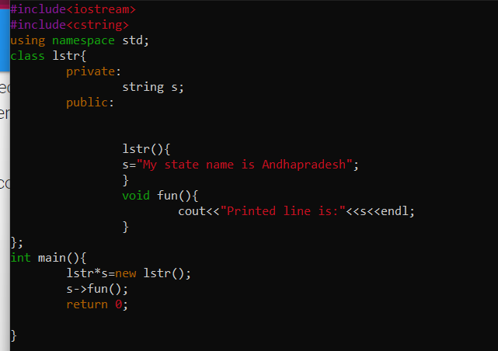

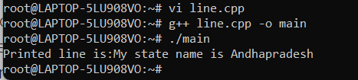

**OSTR/02 Extract every word and store in an array of 5 char pointers dynamically allocating memory.**

**Ans:**

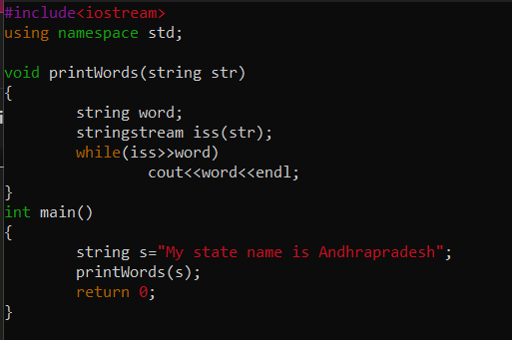

**OSTR/03 Print the longest word in the sentence (assume all words are of different length).**

**Ans:**

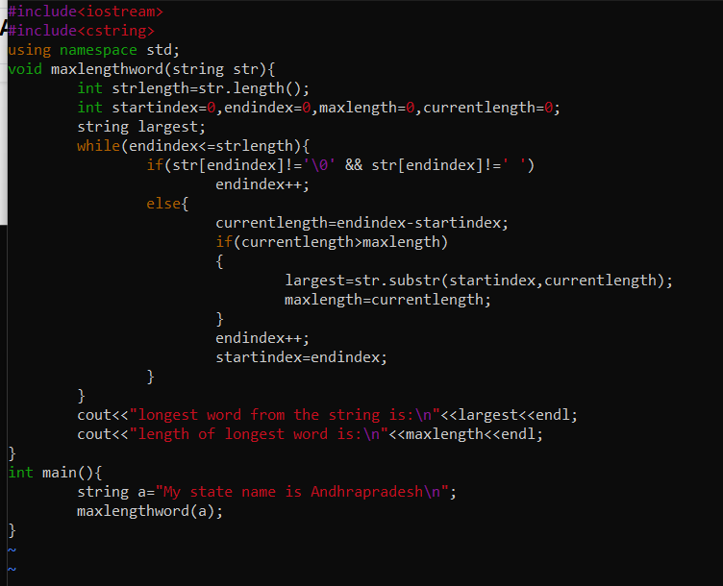

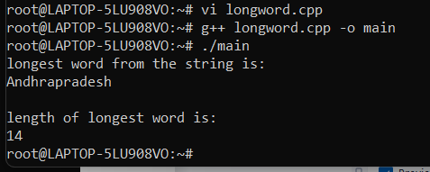

**OSTR/04 Read a word and a replace word from user. Perform search-replace. (Replace only the first matching word).**

**Ans:**

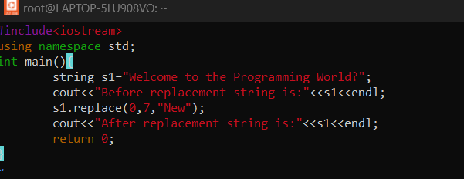

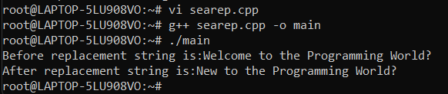

**OSTR/05 Display all the words.**

**Ans:**

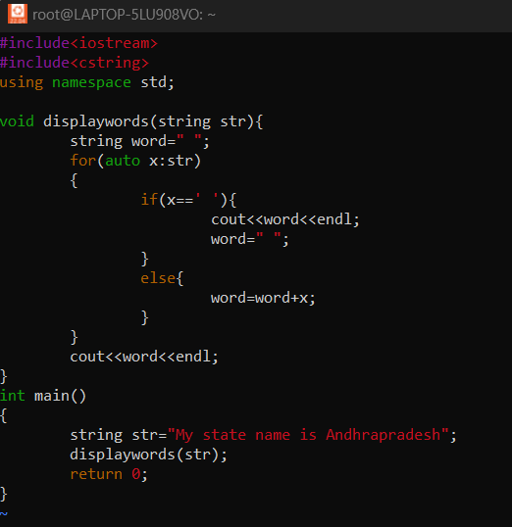

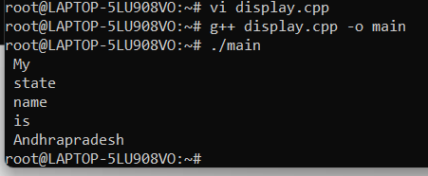

**OSTR/06 Free all the allocated memory on exit**

**Ans: B**y using pointer and at the end of the program

Use the syntax , **free(ptr);**